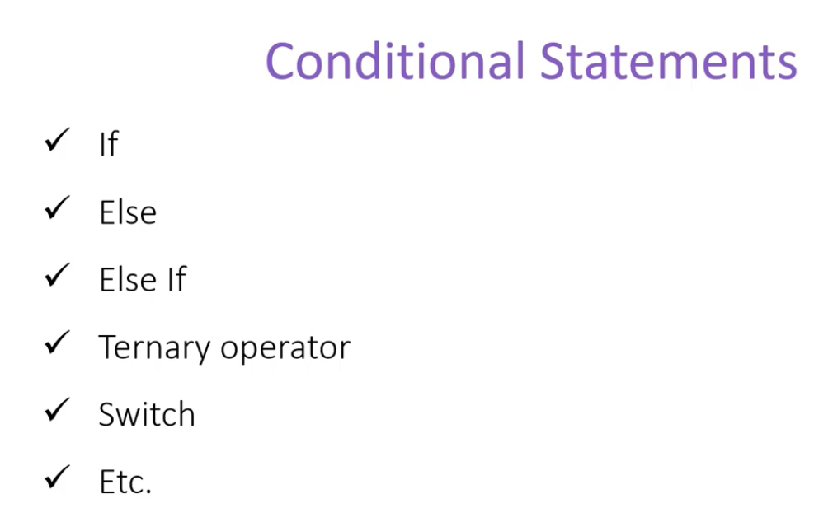

We don’t need to write @ on every line or before every variable in razor pages.

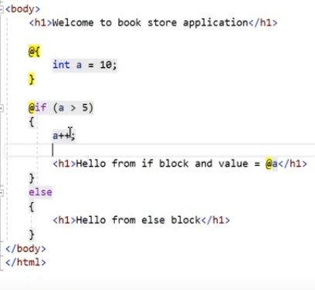

For example, the code here will produce as a =11. Even though we didn’t specify the @.

**Ternary Operator:**

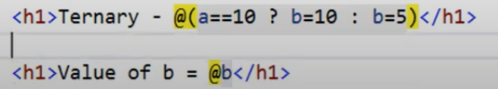

**Switch :**

